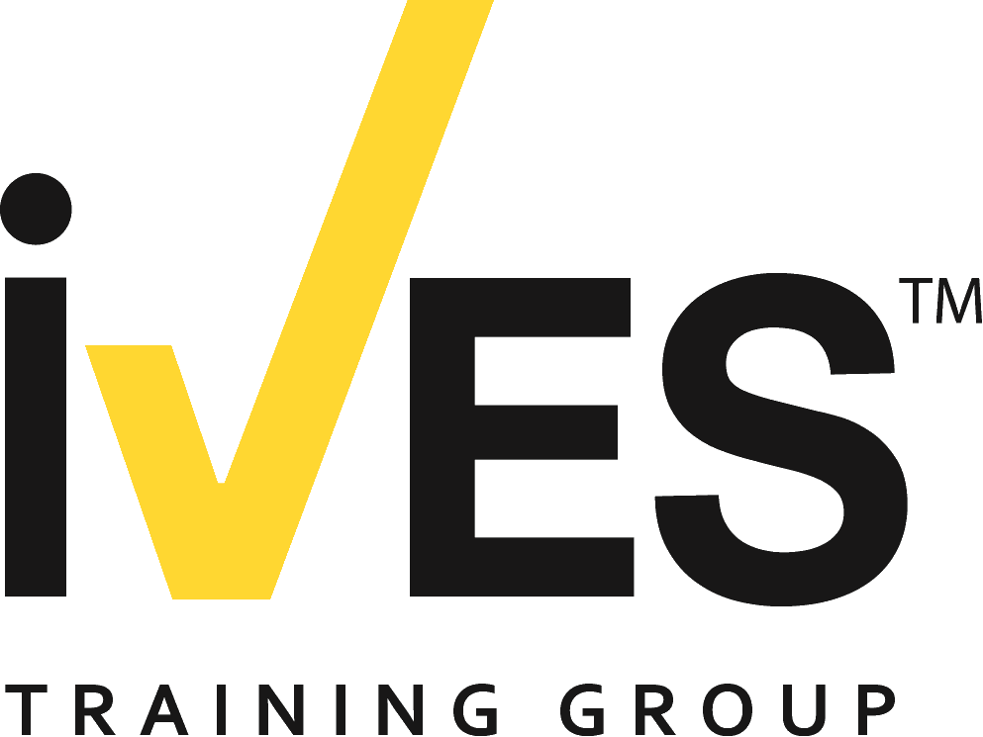
Tips for Gaining Employer Support
Attending an IVES Trainer Certification Program may be the most cost-effective educational choice you will make all year. You will gain new and greater knowledge plus practical skills and techniques that you can apply directly to your job of training mobile equipment operators.
When you propose to attend an IVES Trainer Certification Program, focus specifically on what you will bring back to the company to demonstrate return on investment.
Here are a few tips on gaining employer support:
- Offer to deliver a short meeting and Q&A to your colleagues or team members after the program to share what you learn; which means they will get the benefits of your attendance too.
- Be ready with an idea of who will cover for you while you are attending the program.
- Take time to understand your company’s needs and then what specific components of the program will help it the most.
- Emphasize the benefits of how attending will enable you and your company to meet and interact with safety and training professionals in similar roles from companies across the country.
- Elaborate on how you will gain valuable information and skills that will help bring your mobile equipment operator training into regulatory compliance and protect your company from liability.
Understanding Your Program Expenses
Before you can even begin to justify program expenses you need to calculate what those expenses are. Here is the best way to come up with your expenses.
Registration Fee – Your registration cost is a flat fee depending on which program you attend.
Travel – You will need to calculate the cost of getting to the program by airfare or mileage, depending on how close you are to the location. At select programs lunch will be provided, but a reimbursement cost may need to be calculated for additional meals. You will need to calculate hotel costs and also transportation to and from the hotel and program.

SAMPLE Letter to Supervisor
Here’s a sample letter that you can use in requesting attendance at an IVES Trainer Certification Program.
(Date)
Dear (Supervisor’s Name)
I would like to attend the IVES (Program Name) on (Date) in (Location). This trainer program will give me the skills to train and certify mobile equipment operators on (Equipment Type).
This program delves deeply into the theory and workings of the equipment and teaches trainers the instructional techniques involved in how to best communicate these concepts in both a classroom and field environment. A great deal of importance is placed on practical hands-on training and provides the opportunity for trainers to practice, develop and demonstrate techniques and concepts learned in the classroom.
After reviewing the program information, I have identified that attending will allow me to gain knowledge and understanding of how we can improve our operator training program and bring it into a higher degree of compliance with related mandated government regulations.
I am seeking sponsorship for the registration fee, travel expenses to the program, and living expenses during the program. Here is a detailed cost breakdown:
Airfare: ($XXXXX)
Transportation: ($XXXXX)
Hotel: ($XXXXX)
Meals: ($XXXXX)
Registration Fee: ($XXXXX)
The total costs associated with attending this program are: ($XXXXX)
The opportunity for me to develop a regulatory compliant operator training program that will keep our employees safe while potentially eliminating revenue consuming issues like product and equipment damage, down time, increased worker’s compensation premium costs and potential regulatory assessments, among other things, makes my attendance at this IVES Trainer Certification Program a wise investment for our company.
Sincerely,
(Your Name)

